't Vlindertje has been using washable diapers for two years
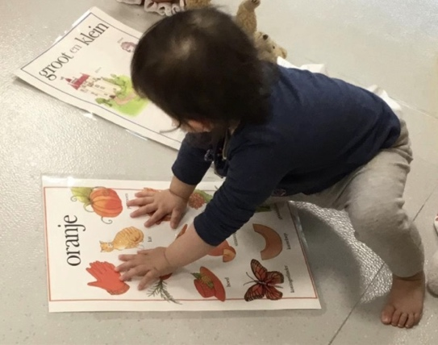
Childcare nowadays is more open to washable nappies than it used to be, despite some unfortunate exceptions. And more and more crèches are opting entirely for washable nappies. When 't Vlindertje in Schoten, Belgium, moved to a new location, it was decided to use reusable nappies for all children, regardless of what nappies they use at home. Klein Spook dropped by for a status check.
From Klein Spook’s recent survey on washable nappies in childcare, we learned that one in eight parents meet a firm ‘no’ when they want to use their cloth nappies in the nursery as well. Not so in Schoten, where initiator Joanna Brzozowska puts the health of the children first. "We all know that there are harmful chemicals in disposable diapers. Surely you don't want that on your children's bottoms?" Based on advice from Klein Spook, 't Vlindertje opted for the Bamboolik inserts and covers. Covers in two colours: yellow for the little ones, brown for the older children. In this way, the nappies are always ready for use for the carers.
The caretakers follow a strict procedure for handling the washable nappies. Each time the children are changed, nappies and covers are placed in separate bins, after which they go to the laundry room. Once washed, the nappies are put in the dryer and the pants are dried on a washing line. It is the task of the person who watches over the children during their afternoon nap to put together the packets of nappies and covers: she takes a few bags of nappies and covers and folds everything ready for use. "We sometimes let the children do the hanging up of the covers themselves, they find that a fun activity," says game coach Greet Steyaert.
After two years Joanna Brzozowska is still very satisfied with her choice, even though there were difficult moments. "Communication is very important," she says. "Not only to the parents, but also to the staff. Washable diapers are not so well known in childcare yet, so there is a certain resistance to them. Occasionally I had to pull rank." The satisfaction also relates to Bamboolik's nappies: "after two years, both the nappies and the covers still look very good, we haven't had to change any of them yet".
In addition to the beautiful ecological garden that 't Vlindertje laid out recently, the washable diapers are one of the important features of this childcare facility. That's why Joanna also promotes the initiative to have the parents use washable nappies at home, and in time she also wants the other branches of 't Vlindertje in Deurne to make the switch.

